G.G. BROCK LABORATORIES
ENGINEERING AND ELECTRICAL RESEARCH
_________

TECHNICAL REPORT 01
_________

ENGINEERING REPORT ON TELLURIC TRANSMISSION COILS FOR BEACON OPERATION

BY

G.G. BROCK

DECEMBER 30, 2021

DEPARTMENT OF RADIO ENGINEERING

PASADENA, CA

CONTENTS
PAGE
6
6
7
8
9

9
12
13

16
16
17

18
18
19
20
28

10
11
14
18
21
22
24
26
27
PRELIMINARY CONSTRUCTION. . . . . . . . . . . . . . . .
Introduction. . . . . . . . . . . . . . . . . . . . . . . .
Initial Design Constraints. . . . . . . . . . . . . . . . .
Scaling Factor. . . . . . . . . . . . . . . . . . . . . . .
FIRST RESULTING PRODUCT. . . . . . . . . . . . . . . . .
Coil Design No. 1. . . . . . . . . . . . . . . . . . . . .
Frequency Analysis. . . . . . . . . . . . . . . . . . . . .
Ground Network Measurements. . . . . . . . . . . . . . . .
SECOND RESULTING PRODUCT. . . . . . . . . . . . . . . .
Coil Design No. 2. . . . . . . . . . . . . . . . . . . . .
Frequency Analysis. . . . . . . . . . . . . . . . . . . . .
THIRD RESULTING PRODUCT. . . . . . . . . . . . . . . . .
Coil Design No. 3. . . . . . . . . . . . . . . . . . . . .
Frequency Analysis. . . . . . . . . . . . . . . . . . . . .
Ground Network Measurements. . . . . . . . . . . . . . . .
Mathematical Analysis. . . . . . . . . . . . . . . . . . .
ILLUSTRATIONS
Fig. 1. Calculate 15 turn coil. . . . . . . . . . . . . . .
Fig. 2. Top view of coil assembly. . . . . . . . . . . . .
Fig. 3. Coil against ground configuration. . . . . . . . .
Fig. 4. Final 21 turn coil design. . . . . . . . . . . . .
Fig. 5. Inductor primary turns to center frequency. . . . .
Fig. 6. Inductor primary turns to mag. factor. . . . . . .
Fig. 7. Dual coil testing configuration. . . . . . . . . .
Fig. 8. Inductor secondary turns to mag. factor. . . . . .
Fig. 9. Inductor secondary turns to bandwidth. . . . . . .

ENGINEERING REPORT ON TELLURIC TRANSMISSION COILS FOR BEACON OPERATION

PRELIMINARY CONSTRUCTION

INTRODUCTION

From the initial development of specialty transmission coils designed for telluric research, the approach to their application in beacon operation has been sought after. That is, the construction of high frequency coils for use in the 160 meter HAM radio band. This has been achieved by rigorous scaling of a preconceived design for non-telluric research, while its construction is still applicable to radio communication. This design is solely composed of four individual coils, arranged in an inward facing direction. Each side possesses two coils, one slender, and one of decent width. The slender coil, the potential coil, possesses a high characteristic impedance coincidentally allowing for the development of a high potential, given the quantity of number of turns on its form. This coil faces inwards so that to face its opposite image, thus allowing for a phase cancellation to arise. Respectively on the opposite sides of these potential coils exists a set of current coils. When the setup is supplied with a moderate degree of radio frequency energy, a balancing action of the current node and potential node will reside in their respective sectors. For now, the current coil will be given attention to, as its proportionalities are to be considered and applied to a larger version. In all matters, this report outlines the development of a practical scale transmission coil, with applicable measurements, mathematical analysis, and proposed operating configurations.

INITIAL DESIGN CONSTRAINTS
PRELIMINARY CONSTRUCTION

The following dimensions concern the construction of a modeled non-telluric current coil intended for research of cosmic induction.

OPERATING FREQUENCY: 7833 kilocycles

LENGTH: 10.16 centimeters

DIAMETER: 15.24 centimeters

LENGTH / DIAMTER FACTOR: 66.66%

WIRE DIAMETER: 0.32639 centimeters

TURN WINDINGS: 15 numeric

LENGTH OF WIRE: 718.16 centimeters

LUMINAL QUARTER WAVELENGTH: 957.48 centimeters

CALCULATED FREQUENCY: 10443 kilocycles

VELOCITY TO THAT OF ‘C’: 75%

EFFECTIVE VELOCITY: $2.25×{10}^{10}$ centimeters per sec.

The above measurements employ the use of copper terminal rings, imposing a capacitive burdening on effective velocity, as well as a decrement on frequency.

Accordingly, the effective copper used during operation, that is, solely the windings themselves, gives;

0.396 cubic inches
Whereby, the effective volume of a given coil is given by the equation,
$E_{v}= π{\left(\frac{d}{2}\right)}^{2}Dπt-π{\left(\frac{d-2\left(\frac{10}{\sqrt{f}}\right)}{2}\right)}^{2}Dπt$
PRELIMINARY CONSTRUCTION
(1)

Equation (1) is properly satisfied if the wire used in question, is of round characteristic and nothing else. Thereby, the effective volume of the wire, $E_{v}$, equals the applied difference of the cylindrical wire volume with respect to frequency. That is, d, is the wire diameter, D, the coil’s diameter, t, the number of turns belonging to the coil, and f, the operating frequency in cycles per second. All other parameters are in units of inches.

SCALING FACTOR

Granted the notion of a scaled coil suited for operation in the 160 meter HAM radio band, the targeted frequency before any loading burdening is to be: 2000 kilocycles.

Hence, the proportion,
(2)
$$S_{f}= \frac{F}{F_{0}}$$

Giving the formulated scaling factor:

$S_{f}= \frac{7833 kc}{2000 kc}$ = 3.9165 numeric

This scaling factor will be employed in all measurement calculations for the determined proportions of the larger transmission coil.

FIRST RESULTING PRODUCT

COIL DESIGN No. 1

Upon using the previous scaling factor with respect to the initial dimensions of the scaling current coil, the following mathematical measurements were gained:

OPERATING FREQUENCY: 2000 kilocycles

LENGTH: 39.79 centimeters

DIAMETER: 59.68 centimeters

LENGTH / DIAMTER FACTOR: 66.66%

WIRE DIAMETER: 0.503 centimeters

TURN WINDINGS: 15 numeric

LENGTH OF WIRE: 2812.67 centimeters

LUMINAL QUARTER WAVELENGTH: 3750 centimeters

CALCULATED FREQUENCY: 2666 kilocycles

COPPER RING DIAMETER: 3.73 centimeters

COPPER RING WALL THICKNESS: 0.34 centimeters

CONDUCTOR SPACING BETWEEN CENTER: 2.65 centimeters

It should be noted that the targeted operating frequency of 2000 kilocycles is to accommodate for capacitive loading of the copper rings, hence, theoretically lowering the total coil operating frequency to 1860 kilocycles. Alongside with incorporation of the ground network, burdening the frequency into its correct place.

FIRST RESULTING PRODUCT
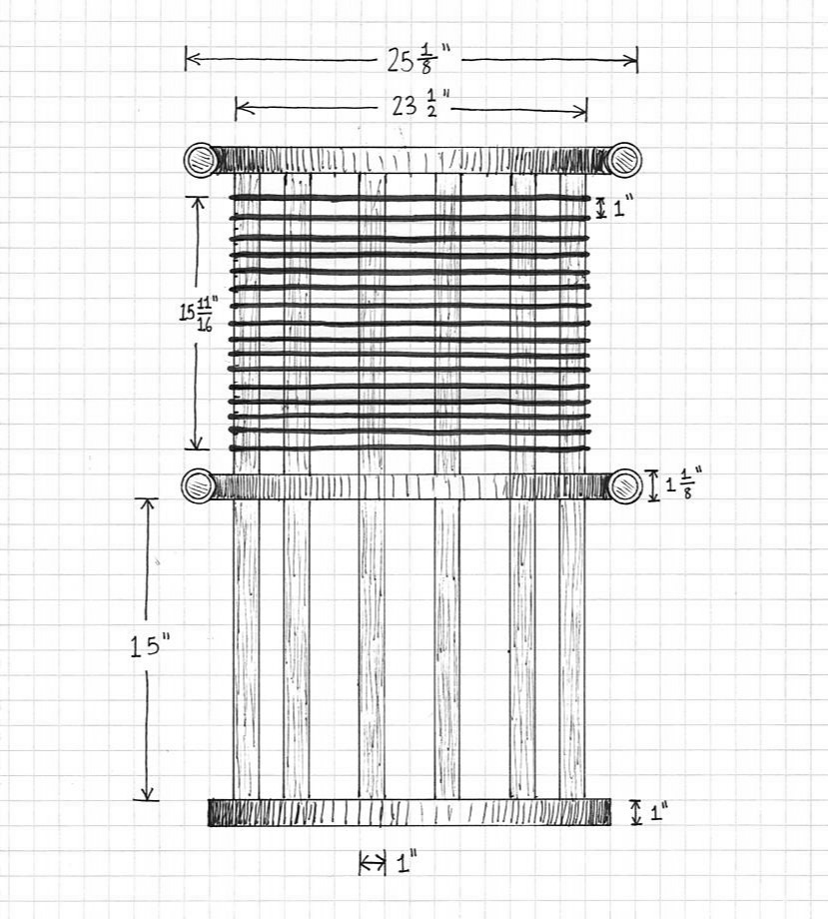

Fig. 1. Calculated 15 turn coil.

FIRST RESULTING PRODUCT

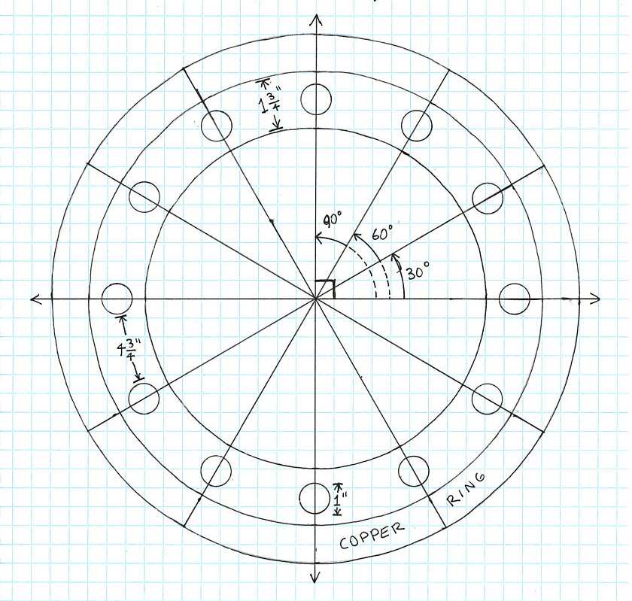

Fig. 2. Top view of coil assembly.

FREQUENCY ANALYSIS
FIRST RESULTING PRODUCT

As a result of economy and unavailability of commercial items, it had become necessary to scale the copper rings slightly less to 2.85 centimeters in diameter, with a wall thickness of 0.31 centimeters.

The following measurements outline the coil with and without its copper rings:

STANDALONE FREQUENCY: 3280 kilocycles

WITH COPPER RINGS: 2810 kilocycles

WITH OXIDATION ON RINGS: 2800 kilocycles

Hence, the standalone velocity, taking into consideration the initial calculated frequency as with respect to light is,

123% that of c

This is arrived at by the proportion,
(1)
$a= \frac{F_{m}}{F_{c}}$

Whereby, $a$, the velocity factor, is proportional to, $F_{m}$,the measured frequency of the coil, and $F_{c}$, the calculated frequency of the coil. The frequency, $F_{c}$, is determined by the quarter wavelength equation, employing the coil’s length of wire, $l$, and the velocity of light, $V_{c}$.
(2)
$F_{c}= \frac{V_{c}}{4l}$

Considering, $a$, from equation (1), the effective velocity the coil will experience is derived by,
(3)
$$V_{0}=aV_{c}$$

Whereby the product of the velocity of light, $V_{c}$, and velocity factor, $a$, gives the effective propagation velocity, $V_{0}$.
FIRST RESULTING PRODUCT

Hence, the effective velocity along the coil is,

$3.69 × {10}^{10}$ centimeters per sec.

With use of the copper loading rings, a difference of 470 kilocycles is achieved, giving the new frequency of the coil as: 2810 kilocycles. By use of equation (1), the resulting velocity percentage becomes,

105.4% that of c

Thus, giving a propagation velocity of,

$3.16 × {10}^{10}$ centimeters per sec.

Taking into account oxidation upon the rings, the velocity factor reduces to,

105% that of c

By use of equation (3), the effective velocity then becomes,

$3. 15× {10}^{10}$ centimeters per sec.

It must be borne in mind that all frequency determinations are made in kilocycles per second, and lengths made in centimeters.

GROUND NETWORK MEASUREMENTS

The following measurements regard the coil being placed in series with a tapped-matching transformer, connected to a low impedance ground network and signal generator. Measurements were taken at a distance with a radio frequency signal strength meter, elevated upon a platform which was directly in line with the top copper ring for maximum reading.
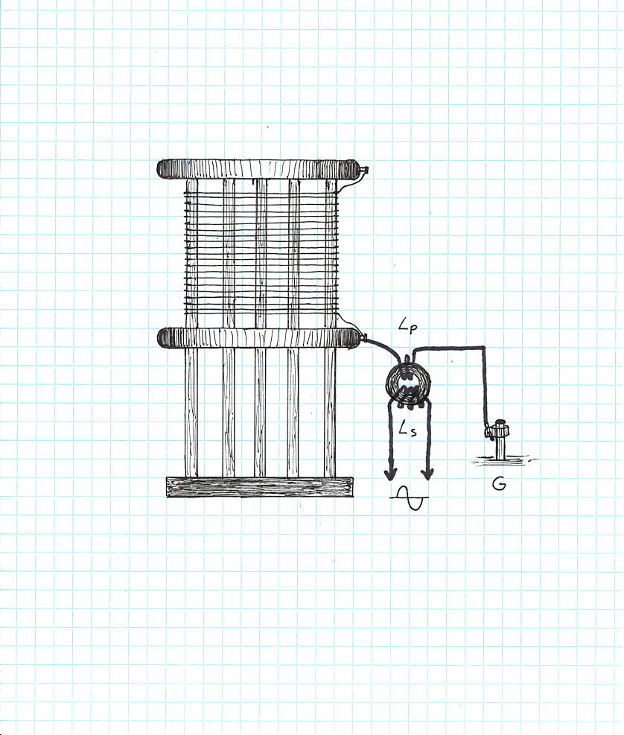
FIRST RESULTING PRODUCT

Fig. 3. Coil against ground configuration.

PRIMARY TURNS ($L_{P}$) | SECONDARY TURNS ($L_{S}$) | FREQUENCY (Kc)
1 | 7 | 2570
1 | 8 | 2580
2 | 8 | 2570
3 | 8 | 2570
4 | 8 | 2570
5 | 8 | 2560
1 | 9 | 2580
2 | 9 | 2570
3 | 9 | 2560
4 | 9 | 2570
5 | 9 | 2560
FIRST RESULTING PRODUCT

Measurements taken with a high impedance ground system, measuring 270,000 ohms, when in series with line neutral:

PRIMARY TURNS ($L_{P}$) | SECONDARY TURNS ($L_{S}$) | FREQUENCY (Kc)
4 | 6 | 2570
1 | 7 | 2580
2 | 7 | 2580
3 | 7 | 2580
4 | 7 | 2570
1 | 8 | 2590
2 | 8 | 2580
3 | 8 | 2580
4 | 8 | 2570

Despite the variability of turns on either side of the inductor core, the operating frequency of the coil presents itself as being too high. In that a higher frequency difference between 730 kilocycles and 700 kilocycles exists, given the goal target frequency of 1860 kilocycles.

It should be noted that in the coil’s expected operation, a ten-foot lead wire between the ground network and impedance matching inductor will exist. This length of wire was tested in the above test measurements and was found to not affect the coil’s operating frequency in any way.
SECOND RESULTING PRODUCT

COIL DESIGN No. 2

As seen from the previous coil construction, the overall frequency ends up being too high for suitable operation. Thus, it is necessary to increase the number of turns on the coil, to approach the targeted frequency. Using measurements from the previous coil regarding the degree of capacitive and ground loading, resulting to frequency decrement, the following equation takes place,
(1)
$$\left[\left(F_{0}η\right)-C_{L}\right]-G_{L}= T_{F}$$

Whereby, the targeted frequency, $T_{F}$, is equal to the product of the original 15 turn coil’s calculated frequency in kilocycles, and the luminal percentage of the coil’s measured frequency from its calculated frequency. The decremental frequency difference the copper rings impose upon the natural measured frequency of the coil in kilocycles, $C_{L}$, is then subtracted from the product, $F_{0}η$. Together, the ground network burdening decremental frequency difference, $G_{L}$, is subtracted from the main expression, giving the targeted frequency. Hence, the expression may be re-arranged so that to solve for the unknown frequency, $F_{0}$. In this circumstance the following equation takes form,

$$\left[\left(F_{0}× 123\%\right)-470\right]-240= 1860$$

Hence,

$F_{0}= 2089$ kilocycles

Given the resultant frequency, it is necessary to determine the respective number of turns the coil will require. This is developed with respect to the coil’s diameter.
(2)
$$\frac{V_{C}}{4F_{0}Dπ}=T_{N}$$
Whereby the number of turns required, $T_{N}$, is equal to the quotient of the velocity of light in centimeters per second, $V_{C}$, divided by the product of four times the determined frequency in cycles per second, $F_{0}$, and the coil’s circumference, $Dπ$.
SECOND RESULTING PRODUCT

Therefore, the required number of turns is:

$$\frac{3×{10}^{10}}{4×2,089,000×59.68π}=T_{N}$$

Hence,

$$T_{N}=19$$

To accommodate for error, the coil was wound with an additional three turns, making for 22 turns in total, with a wire spacing of 0.95 centimeters from conductor centers.

FREQUENCY ANALYSIS

MEASURED STANDALONE FREQUENCY: 2230 kilocycles

WITH COPPER RINGS: 1916 kilocycles

WITH 1:7 TOROID WINDING: 1781 kilocycles

The above measurements indicate the coil operating 79 kilocycles lower from the targeted frequency of 1860 kilocycles. Thus, the removal of a few turns is necessary to lessen the capacitive burdening of the compounded wire itself. Despite the variations of the series connected impedance matching inductor, a very minute frequency difference occurs. Therefore, posing no significant change to the coil’s natural operating frequency.

THIRD RESULTING PRODUCT

COIL DESIGN No. 3

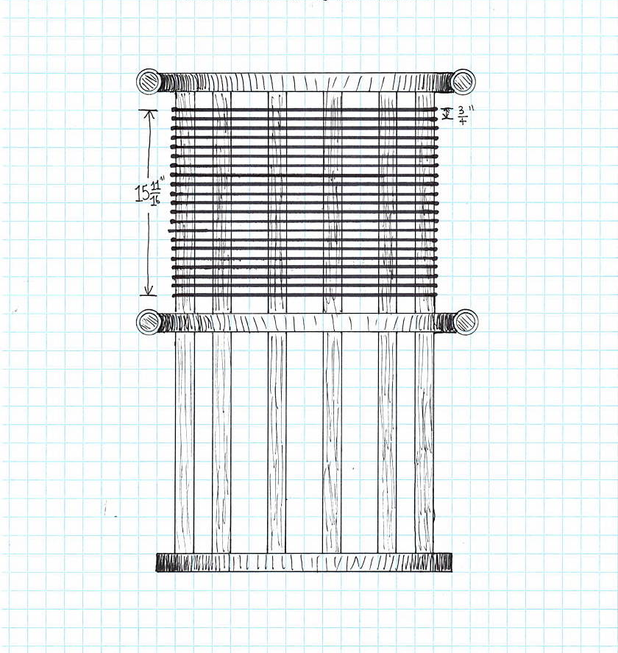

Fig. 4. Final 21 turn coil design.

As in the previous coil design, this final construction outlined, comprises the exact some length and diameter parameters as originally described. The only differences in physicality relate to the wire turns and frequency.
THIRD RESULTING PRODUCT

FREQUENCY ANALYSIS

WIRE SPACING BETWEEN CENTERS: 2 centimeters

TOTAL LENGTH OF WIRE: 3937 centimeters

NUMBER OF TURNS: 21 numeric

STANDALONE FREQUENCY: 2380 kilocycles

FREQUENCY WITH RINGS: 2060 kilocycles

CALCULATED QUARTER WAVE FREQUENCY: 1904 kilocycles

As noticed in the previous coil design, as well as with the now final 21 turn coil, exists a remaining 200 kilocycle gap between the burdened frequency with the added copper rings, and that to be experience with loading from the ground inductor.

Given the equations used in the previous sections, the luminal velocity factor of the coil without its copper rings becomes,

125% that of c

Equating to a propagating velocity of,

$3. 75× {10}^{10}$ centimeters per sec.

Similarly, the addition of copper rings reduces the coil’s velocity factor to,

108% that of c
THIRD RESULTING PRODUCT

Hence the effective velocity becomes,

$3. 24× {10}^{10}$ centimeters per sec.

GROUND NETWORK MEASUREMENTS

The following outlines measurements taken in the configuration as shown in figure 3, employing an inductor.

SEC.  TURNS $L_{S}$ | PRI.  TURNS $L_{P}$ | CENTER  FREQ. | UPPER  FREQ. | LOWER  FREQ. | BANDWIDTH  ΔF | MAGNIFICATION  FACTOR
10 | 5 | 1855 | 1864 | 1848 | 16 | 116
10 | 4 | 1858 | 1867 | 1852 | 15 | 123
10 | 3 | 1863 | 1870 | 1856 | 14 | 133
10 | 2 | 1865 | 1871 | 1859 | 12 | 155
10 | 1 | 1862 | 1869 | 1857 | 12 | 155
9 | 5 | 1855 | 1865 | 1847 | 18 | 103
9 | 4 | 1860 | 1868 | 1853 | 15 | 124
9 | 3 | 1863 | 1870 | 1856 | 14 | 133
9 | 2 | 1864 | 1870 | 1858 | 12 | 155
9 | 1 | 1863 | 1870 | 1857 | 13 | 143
8 | 5 | 1854 | 1865 | 1846 | 19 | 97
8 | 4 | 1861 | 1868 | 1852 | 16 | 116
8 | 3 | 1864 | 1870 | 1856 | 14 | 133
8 | 2 | 1865 | 1871 | 1859 | 12 | 155
8 | 1 | 1864 | 1871 | 1857 | 14 | 133
7 | 5 | 1854 | 1866 | 1844 | 22 | 84
7 | 4 | 1860 | 1869 | 1851 | 18 | 103
7 | 3 | 1862 | 1871 | 1854 | 17 | 109
7 | 2 | 1864 | 1871 | 1857 | 14 | 133
7 | 1 | 1864 | 1872 | 1858 | 14 | 133
6 | 5 | 1852 | 1866 | 1841 | 25 | 74
6 | 4 | 1860 | 1870 | 1850 | 20 | 93
6 | 3 | 1863 | 1871 | 1854 | 17 | 109
6 | 2 | 1865 | 1872 | 1858 | 14 | 133
6 | 1 | 1865 | 1871 | 1859 | 12 | 155
THIRD RESULTING PRODUCT
CENTER FREQUENCY IN KILOCYCLES
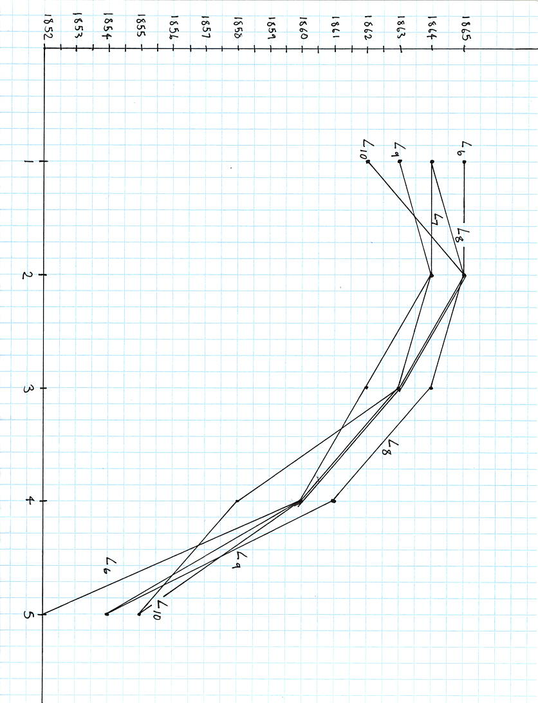

SECONDARY WINDINGS ($L_{S}$) INDICATED NEXT TO CORRESPONDING LINE

INDUCTOR PRIMARY TURNS ($L_{P}$)

INDUCTOR PRIMARY TURNS TO CENTER FREQUENCY

Fig. 5

THIRD RESULTING PRODUCT
NUMERICAL MAGNIFICATION FACTOR
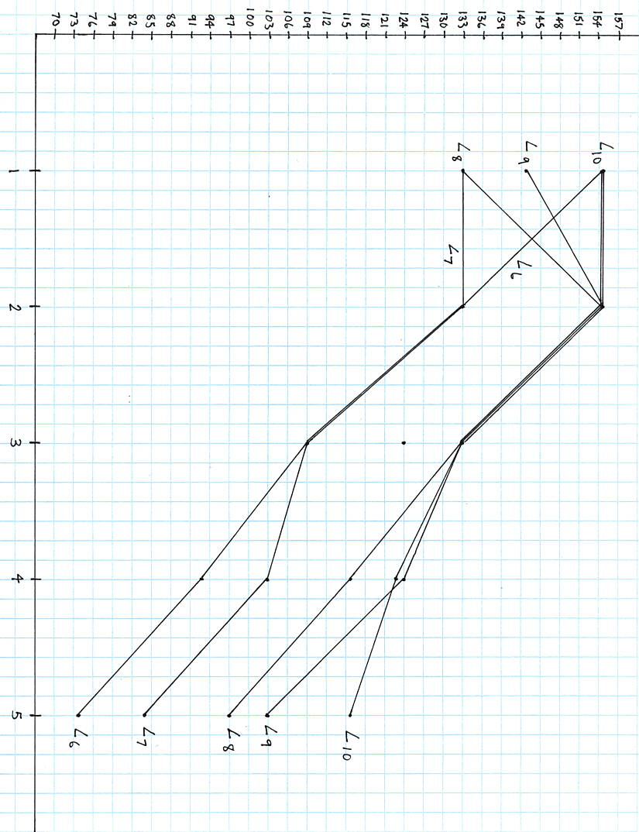

SECONDARY WINDINGS ($L_{S}$) INDICATED NEXT TO CORRESPONDING LINE

INDUCTOR PRIMARY TURNS ($L_{P}$)
INDUCTOR PRIMARY TURNS TO MAGNIFICATION FACTOR

Fig. 6

Based on the previous measurements made, it may be determined that the optimum inductor configuration exists as a 1:10 winding ratio. This allows for a two kilocycle difference with respect to 1860 kilocycles, and provides the highest magnification factor achievable with one coil operation. Whereas if slight frequency excess is preferred for any ground-loading accommodations, then the following winding ratios would be necessary:
THIRD RESULTING PRODUCT

2:10 , 1865 kc , 155 mag.

2:9 , 1864 kc , 155 mag.

2:8 , 1865 kc , 155 mag.

1:6 , 1865 kc , 155 mag.

The ratios with the highest magnification factor, 155, are listed below with their propagation velocity and luminal factor of that of light.

SEC.  TURNS $L_{S}$ | PRI.  TURNS $L_{P}$ | CENTER  FREQ. | LUMINAL  VELOCITY | EFFECTIVE  VELOCITY
10 | 1 | 1862 | 97.79% | $$2.9337× {10}^{10}$$
10 | 2 | 1865 | 97.95% | $$2.9385× {10}^{10}$$
9 | 2 | 1864 | 97.89% | $$2.9367× {10}^{10}$$
8 | 2 | 1865 | 97.95% | $$2.9385× {10}^{10}$$
6 | 1 | 1865 | 97.95% | $$2.9385× {10}^{10}$$

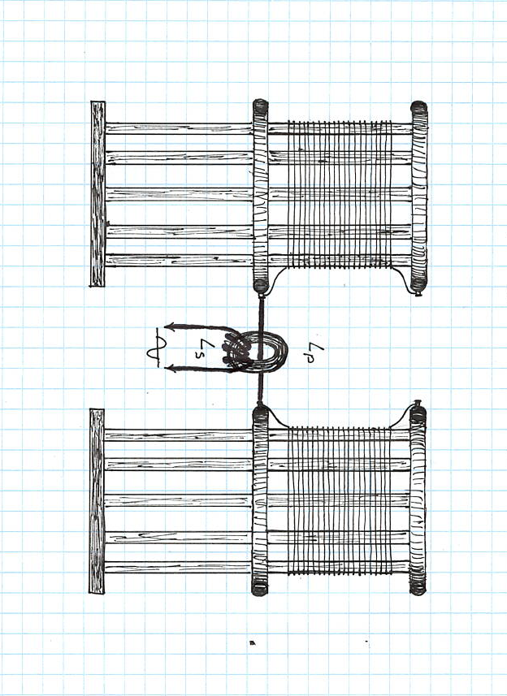
THIRD RESULTING PRODUCT

Fig. 7 Dual coil testing configuration.

The following measurements indicate the combination of two identical coils acting in opposite action, that is, producing a 180 degree phase cancellation located between the spacing center of both coils. The bottom terminal of each coil is connected to either end of the single primary wire, coupling to the inductor with variable turns as indicated in figure 7. The primary winding is kept to a single passing wire, given the low natural impedance of the coil, whereby such a primary configuration allows for higher magnification to be obtained.
THIRD RESULTING PRODUCT

SEC.  TURNS $L_{S}$ | PRI.  TURNS $L_{P}$ | CENTER  FREQ. | UPPER  FREQ. | LOWER  FREQ. | BANDWIDTH  ΔF | MAGNIFICATION  FACTOR
10 | 1 | 1779 | 1781 | 1774.8 | 6.2 | 286.93
9 | 1 | 1778 | 1781 | 1775.3 | 5.7 | 311.92
8 | 1 | 1778 | 1781.5 | 1775.3 | 6.2 | 286.77
7 | 1 | 1778 | 1781.4 | 1775.6 | 5.8 | 306.55
6 | 1 | 1778 | 1781.5 | 1775.9 | 5.6 | 317.50
5 | 1 | 1778 | 1781.4 | 1776 | 5.4 | 329.25
4 | 1 | 1779 | 1781.7 | 1776 | 5.7 | 312.10
3 | 1 | 1779 | 1781.8 | 1775.7 | 6.1 | 291.63
2 | 1 | 1779 | 1781.8 | 1781.8 | 6.8 | 261.61
1 | 1 | 1778 | 1780.8 | 1780.8 | 6.2 | 286.77

Regarding toroid configurations with the highest magnification factor, it may be found that in instances where the center frequency is 1779 kilocycles, the corresponding luminal velocity equates to,

93.38% that of c

Therefore, the velocity is,

$2.80× {10}^{10}$ centimeters per sec.

NUMERICAL MAGNIFICATION FACTOR
THIRD RESULTING PRODUCT
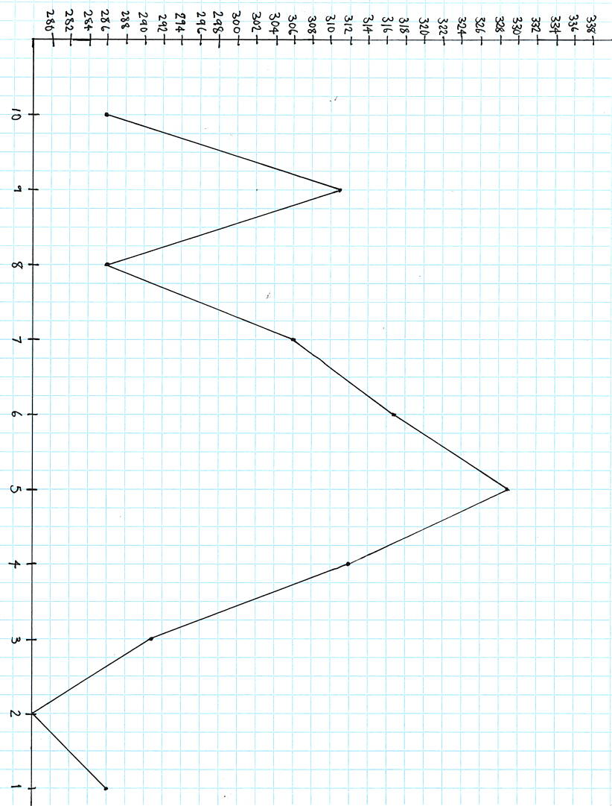

INDUCTOR SECONDARY TURNS ($L_{S}$)

INDUCTOR SECONDARY TURNS TO MAGNIFICATION FACTOR

Fig. 8
THIRD RESULTING PRODUCT
BANDWIDTH (KILOCYCLES)

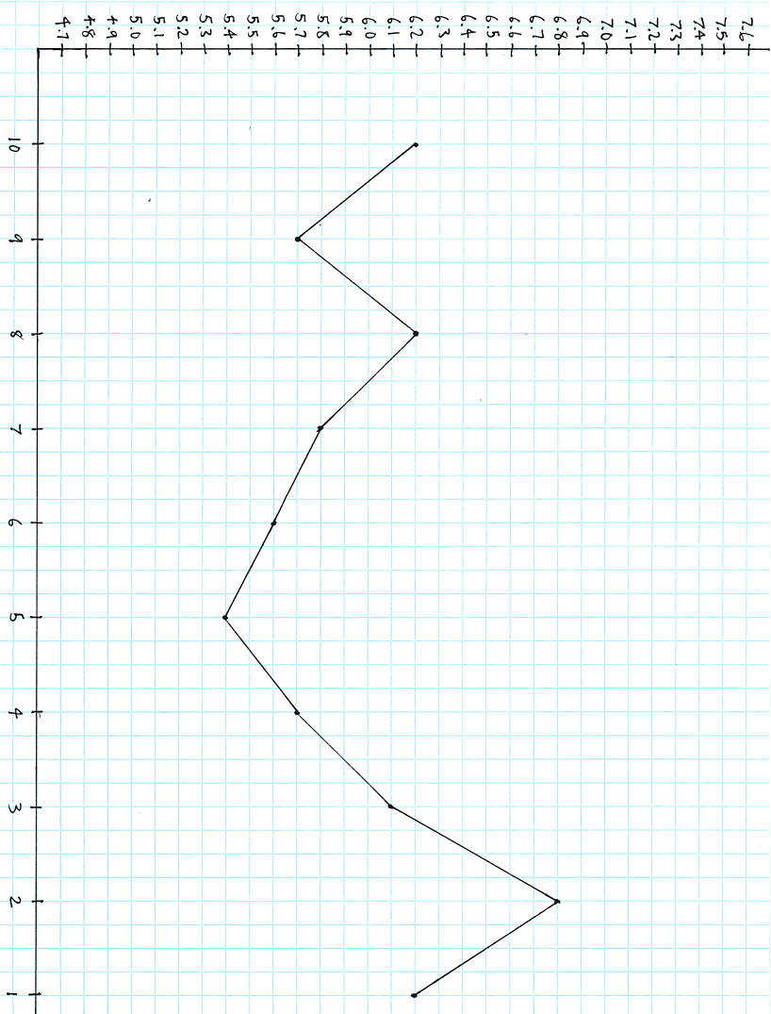

INDUCTOR SECONDARY TURNS ($L_{S}$)

INDUCTOR SECONDARY TURNS TO BANDWIDTH

Fig. 9

Figures 8 and 9 depict the relation between bandwidth and magnification factor of the dual coil setup. It should be noted that the primary was kept constant all throughout, retaining its single wire feed-through configuration.
THIRD RESULTING PRODUCT

MATHEMATICAL ANALYSIS

Using measurements obtained previously for a single 21 turn coil, this section will mathematically analyze certain factors at play, concerning certain properties of the coil.

Regarding the coil’s inductive and capacitive parameters for a standalone situation,
(1)
$$L_{C}= \frac{r^{2}+ N^{2}}{\left(9r+10l\right)}{10}^{-6}$$

Whereby, $L_{C}$, is the calculated inductance in Henries, $r$, the coil’s radius in inches, $N$, the number of turns, and, $l$, the coil’s length in inches.

Hence,
$$L_{C}= \frac{{11.74}^{2}×{21}^{2}}{\left(9\left(11.74\right)+10\left(15.66\right)\right)}{10}^{-6}$$

$L_{C}=$ 231.0 $×{10}^{-6}$ Henries

Comparing this value to the originally measured value of 230 microhenries, the calculated value is essentially the same.

As for capacitance,
(2)
$$C_{0}=HD×{10}^{-12}$$

Where that the capacitance of the coil in Farads, $C_{0}$, is equal to the product of the numerical size factor, $H$, and the coil’s diameter in centimeters, $D$.

Thereby,
THIRD RESULTING PRODUCT
$$C_{0}=\left(0.485\right)\left(59.68\right)×{10}^{-12}$$

$C_{0}=2.89×{10}^{-11}$ Farads

Accordingly, the calculated inductance and capacitance may be inserted into the following equation,
(3)
$$F=\frac{1}{2π\sqrt{L_{C}C_{0}}}$$

Hence,

$$F=\frac{1}{2π\sqrt{\left(231.0 ×{10}^{-6}\right)\left(2.89×{10}^{-11}\right)}}$$

$F=1947$ kilocycles

Since this derived value is quite low for what the true frequency of the coil was measured to be with the rings, that is, 2060 kilocycles, the calculated capacitance, $C_{0}$, must be slightly lower. Therefore, if the measured inductance is the same as the calculated inductance, equation (3) may be re-arranged so that to solve for $C_{0}$, and give a rough estimate of what the real capacitance value should be.

Thus, equation (3) becomes,
(4)
$$C=\frac{1}{4π^{2}F^{2}L_{C}}$$

Substituting the known values,

$$C=\frac{1}{4π^{2}{2,060,000}^{2}\left(231.0 ×{10}^{-6}\right)}$$

$C=2.58×{10}^{-11}$ Farads

Therefore, the known values of capacitance and inductance for the coil have been derived with a decent degree of estimation and accuracy. With these values determined, it is necessary to calculate the approximate characteristic impedance of the coil as follows,
THIRD RESULTING PRODUCT
(5)
$$Z_{C}=\sqrt{\frac{L_{C}}{C}}$$

Thus,
$$Z_{C}=\sqrt{\frac{231.0 ×{10}^{-6}}{2.58×{10}^{-11}}}$$

$Z_{C}=2,992$ zobel

Respectively, the natural period of energy exchange along the coil is expressed as,
(6)
$$τ=\sqrt{L_{C}C}$$

Substituting the known values gives,

$$τ=\sqrt{\left(231.0 ×{10}^{-6}\right)\left(2.58×{10}^{-11}\right)}$$

$τ=7.7×{10}^{-8}$ second

Taking the inverse of the natural period, gives the numerical value of the effective velocity, as related to frequency and winding length.
(7)
$$u=\frac{1}{\sqrt{L_{C}C}}$$

Hence,
(8)
$$τ^{-1}=\frac{1}{\sqrt{L_{C}C}}$$

Henceforth giving the velocity as,

$u=13,000,000$ units per second

